Analysts use various tools to understand and describe the information system. One of the ways is using structured analysis.

What is Structured Analysis?
Structured Analysis is a development method that allows the analyst to understand the system and its activities in a logical way.
It is a systematic approach, which uses graphical tools that analyze and refine the objectives of an existing system and develop a new system specification which can be easily understandable by user.
It has following attributes −
- It is graphic which specifies the presentation of application.
- It divides the processes so that it gives a clear picture of system flow.
- It is logical rather than physical i.e., the elements of system do not depend on vendor or hardware.
- It is an approach that works from high-level overviews to lower-level details.

Structured Analysis Tools
During Structured Analysis, various tools and techniques are used for system development. They are −
- Data Flow Diagrams
- Data Dictionary
- Decision Trees
- Decision Tables
- Structured English
- Pseudocode
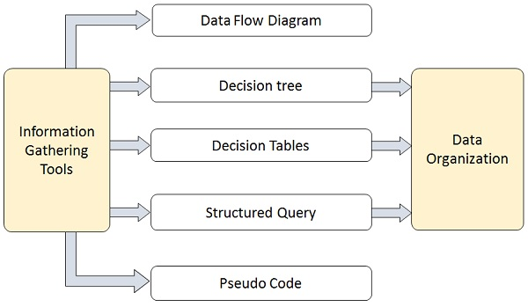

Data Flow Diagrams (DFD) or Bubble Chart
It is a technique developed by Larry Constantine to express the requirements of system in a graphical form.
- It shows the flow of data between various functions of system and specifies how the current system is implemented.
- It is an initial stage of design phase that functionally divides the requirement specifications down to the lowest level of detail.
- Its graphical nature makes it a good communication tool between user and analyst or analyst and system designer.
- It gives an overview of what data a system processes, what transformations are performed, what data are stored, what results are produced and where they flow.

Basic Elements of DFD
DFD is easy to understand and quite effective when the required design is not clear and the user wants a notational language for communication. However, it requires a large number of iterations for obtaining the most accurate and complete solution.
The following table shows the symbols used in designing a DFD and their significance −
Symbol Name | Symbol | Meaning
Square |  | Source or Destination of Data
Arrow | 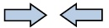 | Data flow
Circle | 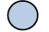 | Process transforming data flow
Open Rectangle | 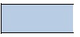 | Data Store

Types of DFD
DFDs are of two types: Physical DFD and Logical DFD. The following table lists the points that differentiate a physical DFD from a logical DFD.
Physical DFD | Logical DFD
It is implementation dependent. It shows which functions are performed. | It is implementation independent. It focuses only on the flow of data between processes.
It provides low level details of hardware, software, files, and people. | It explains events of systems and data required by each event.
It depicts how the current system operates and how a system will be implemented. | It shows how business operates; not how the system can be implemented.

Context Diagram
A context diagram helps in understanding the entire system by one DFD which gives the overview of a system. It starts with mentioning major processes with little details and then goes onto giving more details of the processes with the top-down approach.
The context diagram of mess management is shown below.
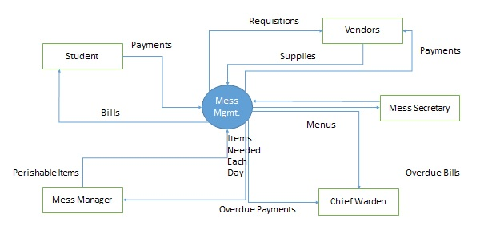

Data Dictionary
A data dictionary is a structured repository of data elements in the system. It stores the descriptions of all DFD data elements that is, details and definitions of data flows, data stores, data stored in data stores, and the processes.
A data dictionary improves the communication between the analyst and the user. It plays an important role in building a database. Most DBMSs have a data dictionary as a standard feature. For example, refer the following table −
Sr.No. | Data Name | Description | No. of Characters
1 | ISBN | ISBN Number | 10
2 | TITLE | title | 60
3 | SUB | Book Subjects | 80
4 | ANAME | Author Name | 15

Decision Trees
Decision trees are a method for defining complex relationships by describing decisions and avoiding the problems in communication. A decision tree is a diagram that shows alternative actions and conditions within horizontal tree framework. Thus, it depicts which conditions to consider first, second, and so on.
Decision trees depict the relationship of each condition and their permissible actions. A square node indicates an action and a circle indicates a condition. It forces analysts to consider the sequence of decisions and identifies the actual decision that must be made.
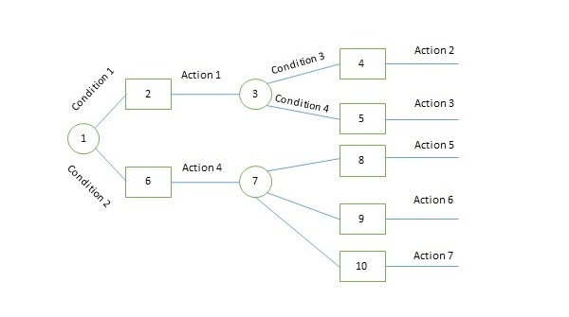
The major limitation of a decision tree is that it lacks information in its format to describe what other combinations of conditions you can take for testing. It is a single representation of the relationships between conditions and actions.
For example, refer the following decision tree −
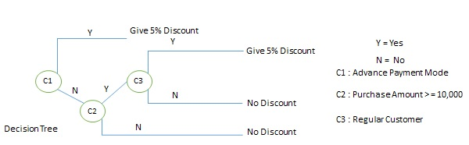

Decision Tables
Decision tables are a method of describing the complex logical relationship in a precise manner which is easily understandable.
- It is useful in situations where the resulting actions depend on the occurrence of one or several combinations of independent conditions.
- It is a matrix containing row or columns for defining a problem and the actions.

Components of a Decision Table
- Condition Stub − It is in the upper left quadrant which lists all the condition to be checked.
- Action Stub − It is in the lower left quadrant which outlines all the action to be carried out to meet such condition.
- Condition Entry − It is in upper right quadrant which provides answers to questions asked in condition stub quadrant.
- Action Entry − It is in lower right quadrant which indicates the appropriate action resulting from the answers to the conditions in the condition entry quadrant.
The entries in decision table are given by Decision Rules which define the relationships between combinations of conditions and courses of action. In rules section,
- Y shows the existence of a condition.
- N represents the condition, which is not satisfied.
- A blank - against action states it is to be ignored.
- X (or a check mark will do) against action states it is to be carried out.
For example, refer the following table −
CONDITIONS | Rule 1 | Rule 2 | Rule 3 | Rule 4
Advance payment made | Y | N | N | N
Purchase amount = Rs 10,000/- | - | Y | Y | N
Regular Customer | - | Y | N | -
ACTIONS
Give 5% discount | X | X | - | -
Give no discount | - | - | X | X

Structured English
Structure English is derived from structured programming language which gives more understandable and precise description of process. It is based on procedural logic that uses construction and imperative sentences designed to perform operation for action.
- It is best used when sequences and loops in a program must be considered and the problem needs sequences of actions with decisions.
- It does not have strict syntax rule. It expresses all logic in terms of sequential decision structures and iterations.
For example, see the following sequence of actions −
if customer pays advance
then
Give 5% Discount
else
if purchase amount >=10,000
then
if the customer is a regular customer
then Give 5% Discount
else No Discount
end if
else No Discount
end if
end if

Pseudocode
A pseudocode does not conform to any programming language and expresses logic in plain English.
- It may specify the physical programming logic without actual coding during and after the physical design.
- It is used in conjunction with structured programming.
- It replaces the flowcharts of a program.

Guidelines for Selecting Appropriate Tools
Use the following guidelines for selecting the most appropriate tool that would suit your requirements −
- Use DFD at high or low level analysis for providing good system documentations.
- Use data dictionary to simplify the structure for meeting the data requirement of the system.
- Use structured English if there are many loops and actions are complex.
- Use decision tables when there are a large number of conditions to check and logic is complex.
- Use decision trees when sequencing of conditions is important and if there are few conditions to be tested.
Analysis Model is a technical representation of the system. It acts as a link between system description and design model. In Analysis Modelling, information, behavior, and functions of the system are defined and translated into the architecture, component, and interface level design in the design modeling.

Objectives of Analysis Modelling:
- It must establish a way of creating software design.
- It must describe the requirements of the customer.
- It must define a set of requirements that can be validated, once the software is built.

Elements of Analysis Model:

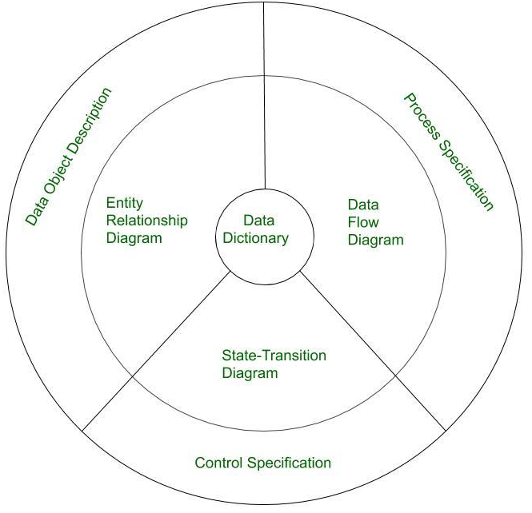

- Data Dictionary:
It is a repository that consists of a description of all data objects used or produced by the software. It stores the collection of data present in the software. It is a very crucial element of the analysis model. It acts as a centralized repository and also helps in modeling data objects defined during software requirements.
- Entity Relationship Diagram (ERD):
It depicts the relationship between data objects and is used in conducting data modeling activities. The attributes of each object in the Entity-Relationship Diagram can be described using Data object description. It provides the basis for activity related to data design.
- Data Flow Diagram (DFD):
It depicts the functions that transform data flow and it also shows how data is transformed when moving from input to output. It provides the additional information which is used during the analysis of the information domain and serves as a basis for the modeling of function. It also enables the engineer to develop models of functional and information domains at the same time.
- State Transition Diagram:
It shows various modes of behavior (states) of the system and also shows the transitions from one state to another state in the system. It also provides the details of how the system behaves due to the consequences of external events. It represents the behavior of a system by presenting its states and the events that cause the system to change state. It also describes what actions are taken due to the occurrence of a particular event.
- Process Specification:
It stores the description of each function present in the data flow diagram. It describes the input to a function, the algorithm that is applied for the transformation of input, and the output that is produced. It also shows regulations and barriers imposed on the performance characteristics that are applicable to the process and layout constraints that could influence the way in which the process will be implemented.
- Control Specification:
It stores additional information about the control aspects of the software. It is used to indicate how the software behaves when an event occurs and which processes are invoked due to the occurrence of the event. It also provides the details of the processes which are executed to manage events.
- Data Object Description:
It stores and provides complete knowledge about a data object present and used in the software. It also gives us the details of attributes of the data object present in the Entity Relationship Diagram. Hence, it incorporates all the data objects and their attributes.

Elements of the analysis model
1. Scenario based element
- This type of element represents the system user point of view.
- Scenario based elements are use case diagram, user stories.
2. Class based elements
- The object of this type of element manipulated by the system.
- It defines the object,attributes and relationship.
- The collaboration is occurring between the classes.
- Class based elements are the class diagram, collaboration diagram.
3. Behavioral elements
- Behavioral elements represent state of the system and how it is changed by the external events.
- The behavioral elements are sequenced diagram, state diagram.
4. Flow oriented elements
- An information flows through a computer-based system it gets transformed.
- It shows how the data objects are transformed while they flow between the various system functions.
- The flow elements are data flow diagram, control flow diagram.
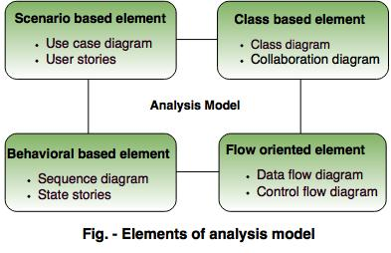

Analysis Rules of Thumb
The rules of thumb that must be followed while creating the analysis model.
The rules are as follows:
- The model focuses on the requirements in the business domain. The level of abstraction must be high i.e there is no need to give details.
- Every element in the model helps in understanding the software requirement and focus on the information, function and behaviour of the system.
- The consideration of infrastructure and nonfunctional model delayed in the design.
For example, the database is required for a system, but the classes, functions and behavior of the database are not initially required. If these are initially considered then there is a delay in the designing.
- Throughout the system minimum coupling is required. The interconnections between the modules is known as 'coupling'.
- The analysis model gives value to all the people related to model.
- The model should be simple as possible. Because simple model always helps in easy understanding of the requirement.

Concepts of data modeling
- Analysis modeling starts with the data modeling.
- The software engineer defines all the data object that proceeds within the system and the relationship between data objects are identified.
Data objects
- The data object is the representation of composite information.
- The composite information means an object has a number of different properties or attribute.
For example, Height is a single value so it is not a valid data object, but dimensions contain the height, the width and depth these are defined as an object.
Data Attributes
Each of the data object has a set of attributes.
Data object has the following characteristics:
- Name an instance of the data object.
- Describe the instance.
- Make reference to another instance in another table.
Relationship
Relationship shows the relationship between data objects and how they are related to each other.
Cardinality
Cardinality state the number of events of one object related to the number of events of another object.
The cardinality expressed as:
One to one (1:1)
One event of an object is related to one event of another object.
For example, one employee has only one ID.
One to many (1:N)
One event of an object is related to many events.
For example, One collage has many departments.
Many to many(M:N)
Many events of one object are related to many events of another object.
For example, many customer place order for many products.
Modality
- If an event relationship is an optional then the modality of relationship is zero.
- If an event of relationship is compulsory then modality of relationship is one.

Requirement modeling strategies
Following are the requirement modeling strategies:
1. Flow Oriented Modeling
2. Class-based Modeling

1. Flow Oriented Modeling
It shows how data objects are transformed by processing the function.
The Flow oriented elements are:
i. Data flow model
- It is a graphical technique. It is used to represent information flow.
- The data objects are flowing within the software and transformed by processing the elements.
- The data objects are represented by labeled arrows. Transformation are represented by circles called as bubbles.
- DFD shown in a hierarchical fashion. The DFD is split into different levels. It also called as 'context level diagram'.
ii. Control flow model
- Large class applications require a control flow modeling.
- The application creates control information instated of reports or displays.
- The applications process the information in specified time.
- An event is implemented as a boolean value.
For example, the boolean values are true or false, on or off, 1 or 0.
iii. Control Specification
- A short term for control specification is CSPEC.
- It represents the behaviour of the system.
- The state diagram in CSPEC is a sequential specification of the behaviour.
- The state diagram includes states, transitions, events and activities.
- State diagram shows the transition from one state to another state if a particular event has occurred.
iv. Process Specification
- A short term for process specification is PSPEC.
- The process specification is used to describe all flow model processes.
- The content of process specification consists narrative text, Program Design Language(PDL) of the process algorithm, mathematical equations, tables or UML activity diagram.

2. Class-based Modeling
- Class based modeling represents the object. The system manipulates the operations.
- The elements of the class based model consist of classes and object, attributes, operations, class – responsibility - collaborator (CRS) models.
Classes
Classes are determined using underlining each noun or noun clause and enter it into the simple table.
Classes are found in following forms:
- External entities: The system, people or the device generates the information that is used by the computer based system.
- Things: The reports, displays, letter, signal are the part of the information domain or the problem.
- Occurrences or events: A property transfer or the completion of a series or robot movements occurs in the context of the system operation.
- Roles: The people like manager, engineer, salesperson are interacting with the system.
- Organizational units: The division, group, team are suitable for an application.
- Places: The manufacturing floor or loading dock from the context of the problem and the overall function of the system.
- Structures: The sensors, computers are defined a class of objects or related classes of objects.
Attributes
Attributes are the set of data objects that are defining a complete class within the context of the problem.
For example, 'employee' is a class and it consists of name, Id, department, designation and salary of the employee are the attributes.
Operations
The operations define the behaviour of an object.
The operations are characterized into following types:
- The operations manipulate the data like adding, modifying, deleting and displaying etc.
- The operations perform a computation.
- The operation monitors the objects for the occurrence of controlling an event.
CRS Modeling
- The CRS stands for Class-Responsibility-Collaborator.
- It provides a simple method for identifying and organizing the classes that are applicable to the system or product requirement.
- Class is an object-oriented class name. It consists of information about sub classes and super class.
- Responsibilities are the attributes and operations that are related to the class.
- Collaborations are identified and determined when a class can achieve each responsibility of it. If the class cannot identify itself, then it needs to interact with another class.

Behavioral patterns for requirement modeling
Behavioral model shows the response of software to an external event.
Steps for creating behavioral patterns for requirement modeling as follows:
- Evaluate all the use cases to completely understand the sequence, interaction within the system.
- Identify the event and understand the relation between the specific event.
- Generate a sequence for each use case.
- Construct a state diagram for the system.
- To verify the accuracy and consistency review the behavioral model.

Software Requirement Specification (SRS)
- The requirements are specified in specific format known as SRS.
- This document is created before starting the development work.
- The software requirement specification is an official document.
- It shows the detail about the performance of expected system.
- SRS indicates to a developer and a customer what is implemented in the software.
- SRS is useful if the software system is developed by the outside contractor.
- SRS must include an interface, functional capabilities, quality, reliability, privacy etc.

Characteristics of SRS
- The SRS should be complete and consistence.
- The modification like logical and hierarchical must be allowed in SRS.
- The requirement should be easy to implement.
- Each requirement should be uniquely identified.
- The statement in SRS must be unambiguous means it should have only one meaning.
- All the requirement must be valid for the specified project.

